# Instructions for running ISEK chatbot

This guide is not perfect and I guarantee I have missed a step or two. If you get stuck stop and let me know. I can just remote into the machine and set it up as well. Good luck!

There are three parts to the ISEK chatbot; the website which is in MVC3, the chatbot which is in PHP and the database that holdsthe conversation text which is in MySQL. This guide will first help you install the software for each piece and then work you through the process of connecting the pieces together.

For help with install please contact Charlie Patterson at [charlespisu@gmail.com](mailto:charlespisu@gmail.com).

## Install of necessary software

1. **MVC3 runs in Visual Studio.** Versions of Visual Studio from 2008 and up will work. The program was developed in Visual Studio 2010. Download Visual Studio 2010 Professional not ultimate.

http://www.microsoft.com/visualstudio/en-gb/try

1. **Install MVC3 software** from the ASP.net website. It is just a framework that adds itself to Visual Studio <http://www.asp.net/mvc/mvc3>
2. **Install of EasyPHP**. EasyPHP is a combination of programs that turns your computer into a virtual server and allows you to run PHP applications on your computer. This install is large and takes some time. <http://www.easyphp.org/save-easyphp-latest.php>
3. **Install of MySQL.** This is a free program but is rather large. The install link is here: <http://dev.mysql.com/downloads/installer/>

Every component should now be installed. To verify that each component installed correctly please perform the following steps as tests for each piece of software.

1. **Open Visual studio and start a new project.** Navigate to Visual C# and then web. At web you should see MVC3 Web Application. Click on it and let it load, then run the program. You should see a basic web site open up in your web browser. Step one complete.

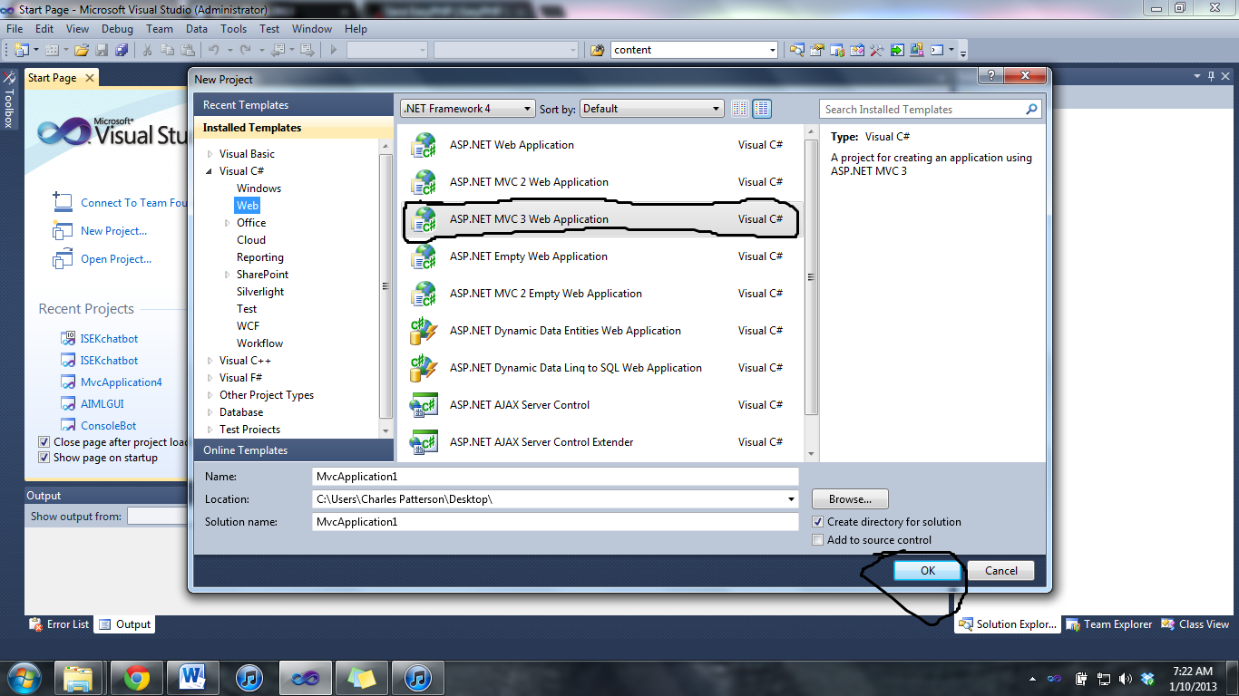

**2) Verify that EasyPHP has installed** by opening it and seeing if you can access the different components. The easiest check is to open EasyPHP, go to the icon menu on the far right bottom hand of the window and right click on the large black E symbol. Navigate to and click on “Local Web”. You should now see another browser window pop up that looks similar to the one below without the ISEK pages in it.

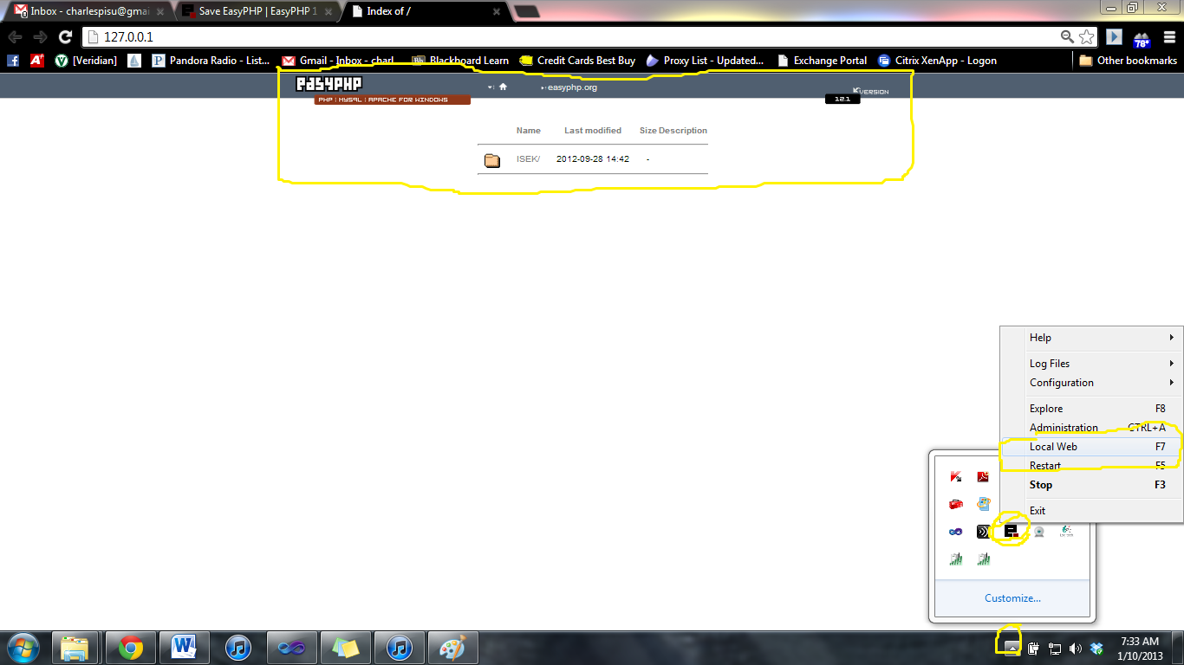

3**) Verify that MySQL has been installed**. Open the MySQL Workbench from the start menu. Access the example data base that comes with the program by double clicking on the Local instance of MySQL located on the workbench central. (See picture)

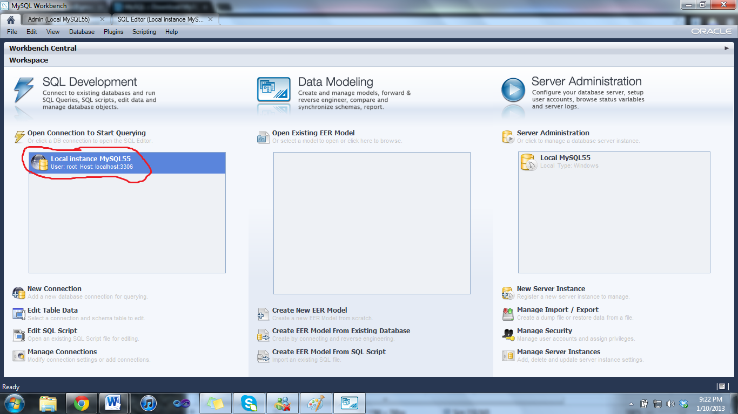

Then verify that there is an object in the list on the right hand side of the page.

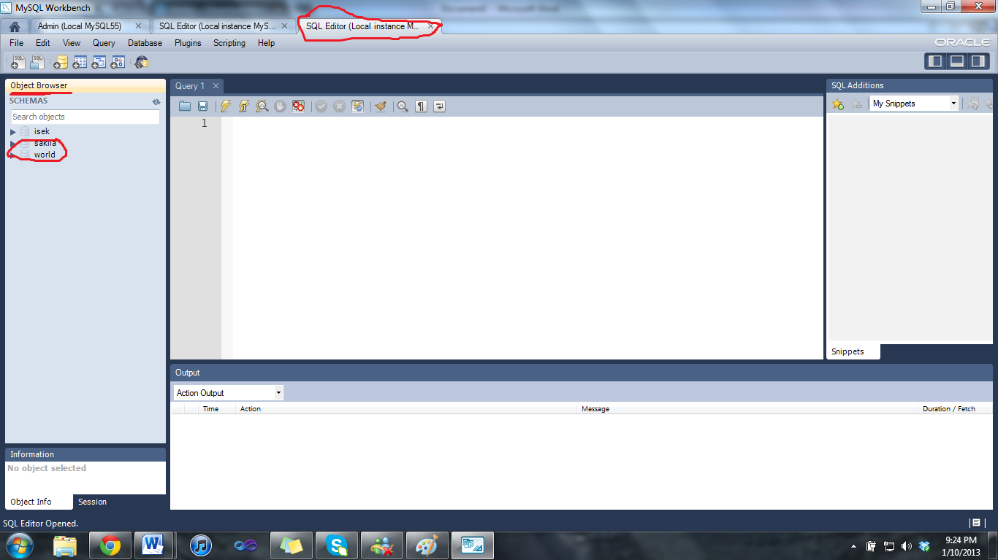

**IF YOU HAVE MADE IT THIS FAR YOU ARE DOING A GREAT JOB! KEEP UP THE GREAT WORK!!!**

## How to run ISEK chatbot

Again we will work through each one of the three components of the project to get a single working project. In the same order as before.

~~First, download the application from GitHub.~~

For now please just use the application in this zip folder as I am having issues with GitHub.

### Install of Web Application

This should be the easiest part. Go to the location you saved the entire project to. Click on the ISEKchatbot with Microsoft Visual Studio. As seen in the picture below.

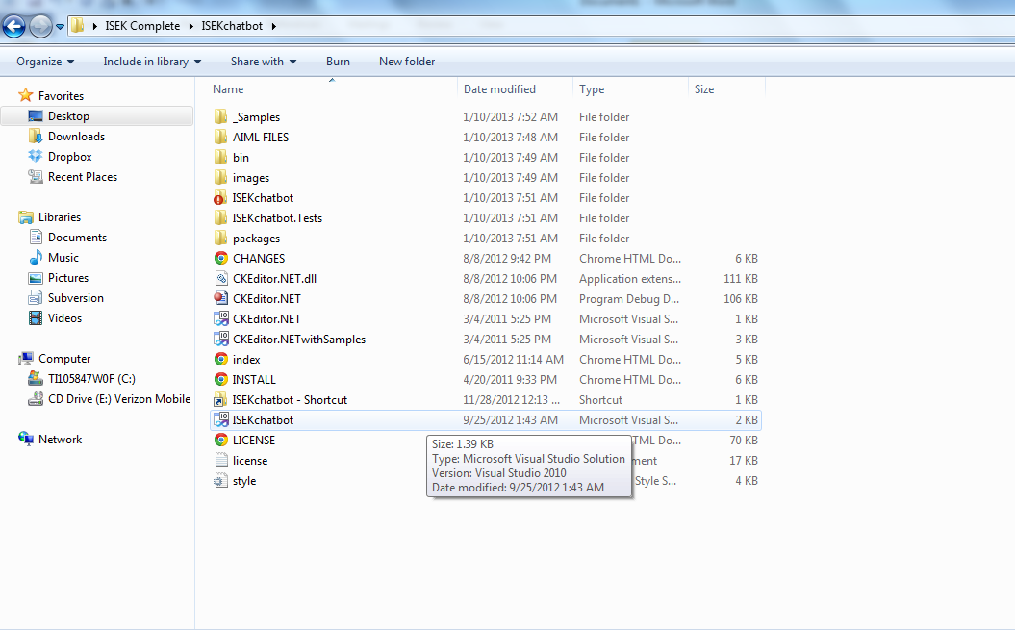

After clicking on the ISEKchatbot a project should open up in Visual Studio. Run the program and you should get an error. In the browser then type in localhost:XXXXX/home to see the web application for the chat bot, but the chat bot should not be working. (The chatbot interface in PHP has not been set up yet)

### Install of PHP chat application

The first step is to copy the entire chat application into the PHP application. To do this simply right click and copy the ISEK folder. Then right click on the EasyPHP application in the bottom corner of the page and navigate to explore. You should then see a file location called www. Please copy the ISEK file into this file location.

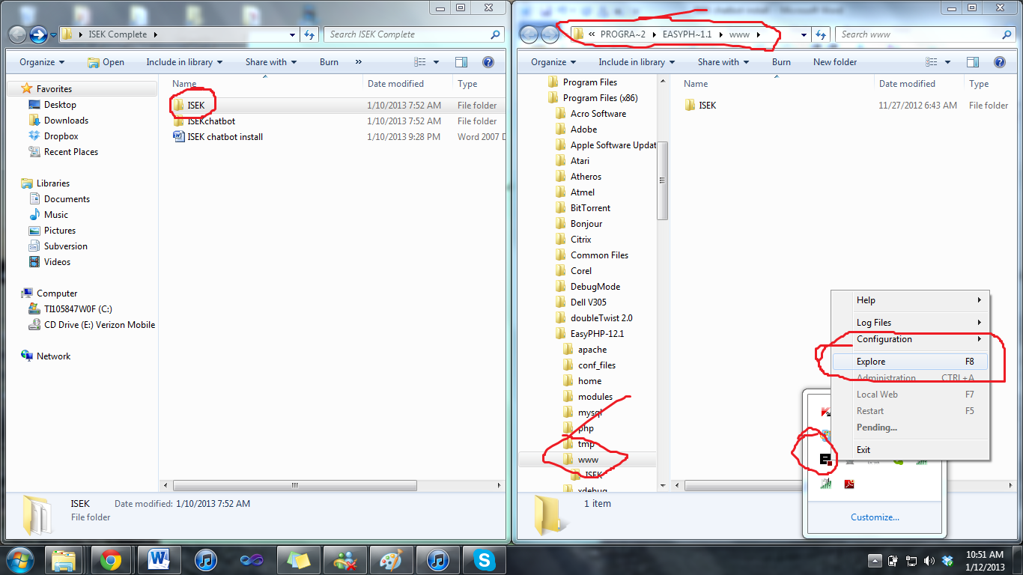

Then click run on the easy PHP to see the program. You should see the chat bar but it will not work. The next step is to configure the database so the pieces of the conversation can be saved.

### Configuration of Database

First, go into MySQL and create a new schema, you can name it anything but remember the credentials you set in it.

Then, navigate to the following page in EasyPHP: <http://127.0.0.1/ISEK/install/install_programo.php>. Here we will set up the database to be connected with ISEK. Fill in the categories as seen in the picture below.

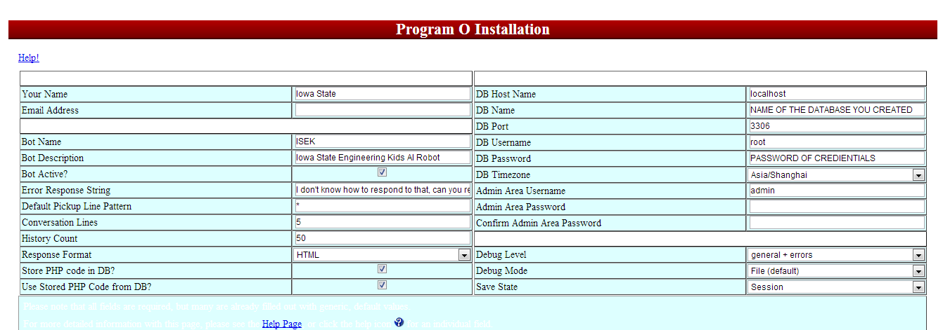

Then navigate to the following page after running the program in Visual Studio to edit the robot settings. Note the AIML files are saved under ISEKchatbot/AIML FILES.

EDIT BOT SETINGS AND CONVO: <http://localhost:50018/Home/SpecialChat>

You will have to log in, the login will be whatever you set the admin password to and the admin username to in the previous image.

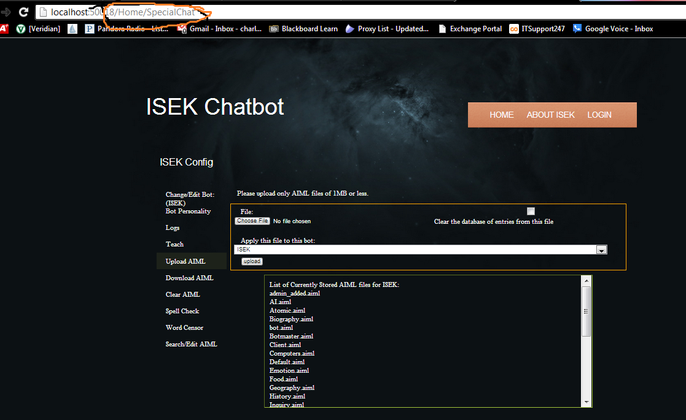

Note: There is still an error with the chat, sometimes an input will not return any output and the chat will stop. This is something I am still working on. To fix this one can manually go through each AIML file are remove the * and <*>, but it is very difficult.

This guide is not perfect and I guarantee I have missed a step or two. If you get stuck stop and let me know. I can just remote into the machine and set it up as well.